**Project Edulead**

**USER MANUAL**

**Student Lifecycle Management System Module-Academics**

**October 2023, Version 1.0**

**Sustainable Outreach and Universal Leadership Limited**

**VERSION HISTORY**

|  |  |  |  |  |
| --- | --- | --- | --- | --- |
| **Date** | **Version No.** | **Created By** | **Updated Section** | **Updated By** |
| 09-10-2023 | Version 0.1 | Nehal Kumar |  |  |
|  |  |  |  |  |

**Content**

About this Manual 2

General Procedures 3

1. Student Group 12

2. Class Schedule 13

3. Student Attendance 14

4. Student Attendance Tool 15

5. Reason for Leave 17

6. Class Advisor and Manager Assignment 17

7. Student Leave Application 18

8. Mentor Allocation 19

9. Communication 20

10. Class Scheduling Tool 21

11. Student Monthly Attendance 23

12. Student Batch Wise Attendance 23

13. Student Attendance Report 23

14. Student Attendance Report for Billing 24

### About this Manual

This User Manual acts as a reference for **EduLead** by describing its various concepts and abilities, and by leading the user through the basics of **EduLead** software. It also provides a detailed reference for all of the **EduLead** SLCM (Student Lifecycle Management) functionalities. The User Manual describes all the processes and functionalities regarding various modules and its abilities to conduct the smooth transactions and integration's within the modules.

The software **EduLead** is open-source, easy to use and customize, actively maintained, economical and well supported. Throughout this manual it is assumed that the reader has a working knowledge of about Student Lifecycle Management and basic computer skills and knows how to:

* Use keyboard and mouse
* Use web browsers to access the **EduLead** website
* Locate, open and save data files.
* Edit, cut, paste and text.

The SLCM consists of 3 Modules mainly:

1. Admission
2. Academics
3. Examination

This User Manual consists of the **Academics Module** for End User reference and guidance. The manual describes how to use the Standard interface. As mentioned, it contains instructions that the users must follow during the operation and servicing of **EduLead**. Diverting from the workflow as mentioned in the user manual may result in errors and non-functioning of the software EduLead. It is advisable that the end users must abide by the instructions as mentioned in the user manual.

**General Procedures**

#### **General Procedures for a Save Screen**

**Create of New document**

1. Login in to the system
2. Go the required workspace, If user have more workspace

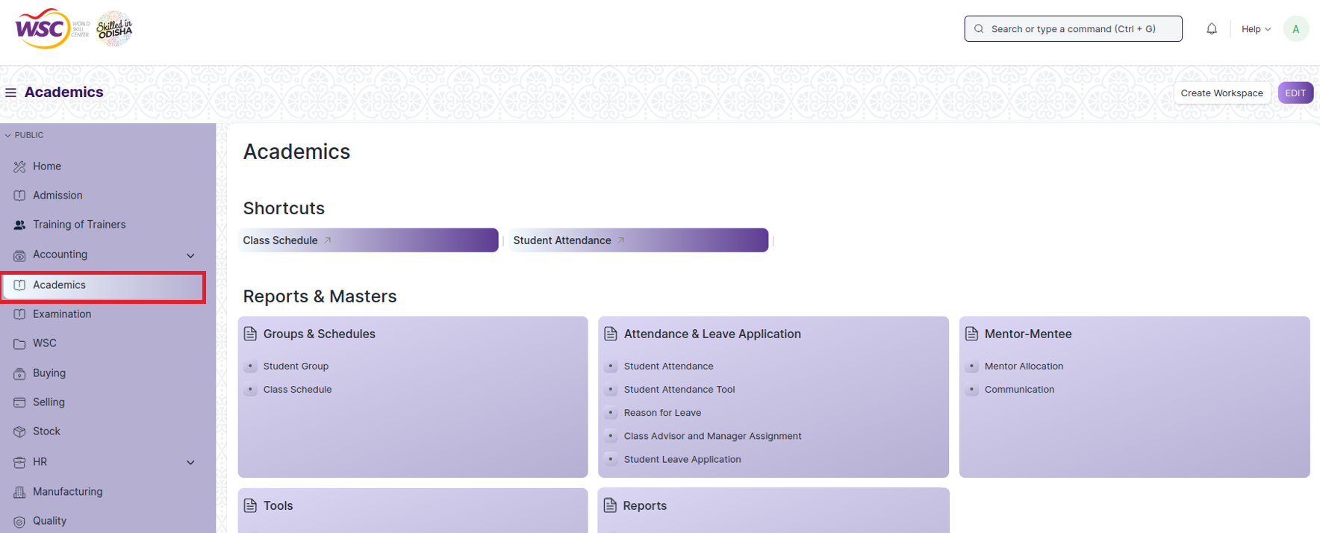

1. Go to the required screen.
2. Click on the ***“+Add Screen Name”*** button in the right corner of the screen.

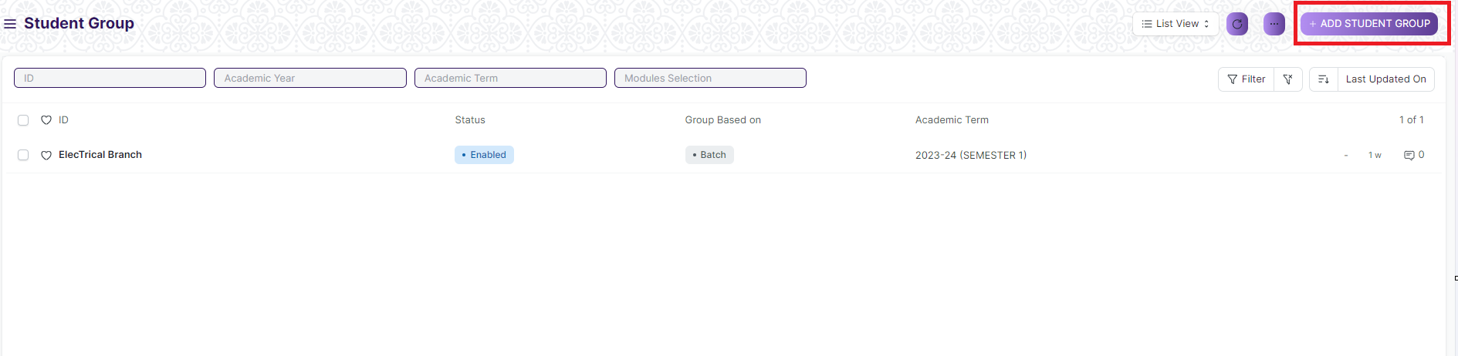

(Example : For addition in the new Student Group , click +Add Student Group button).

1. Enter the required data.
2. Click on “***Save”*.**
3. After saving , the record will be visible in the List View of the screen.

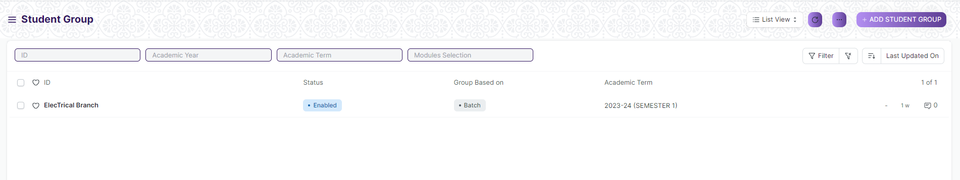

(Example : List view of saved Student Group)

**Note :** The process of creation can only be carried out by User who have necessary permission. Kindly refer to the Screen wise permission section in the document.

**View a Saved Document**

1. Log in to the system.
2. Go to the required workspace
3. Go to the required screen.
4. Click on the required document from the list view of the screen.

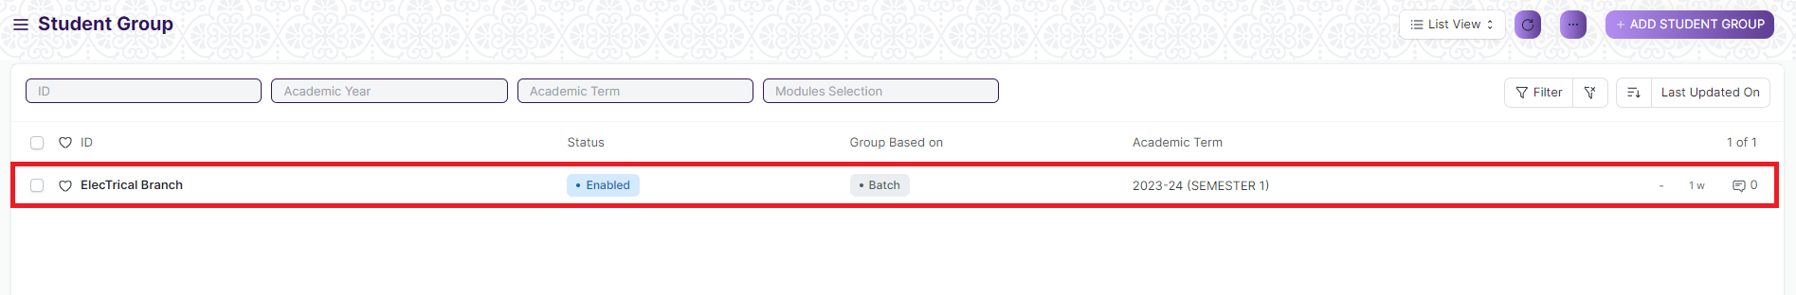

* (Example : View of “ElecTrical Branch” Document of Student Group Screen)

1. View the clicked document.

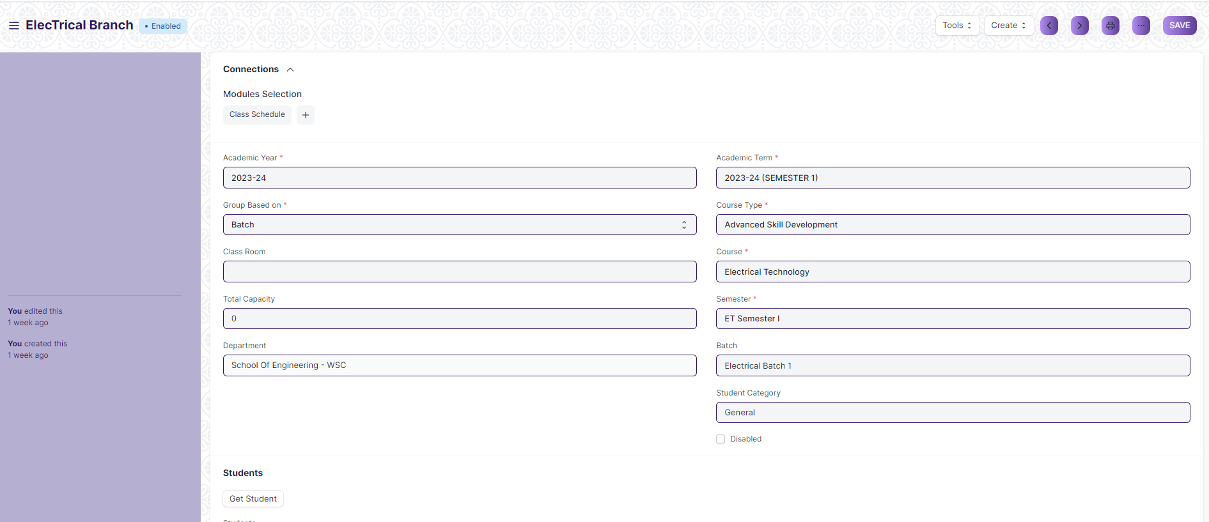

(Example : View of the “ElecTrical Branch” Student Group)

**Note :** The process of view can only be carried out by user who have necessary permission. Kindly refer to the Screen wise permission section in the document.

**Delete a Saved Document**

1. Log in to the system
2. Go to the required workspace
3. Go to the required screen.
4. Click on the required document from the list view of the screen.
5. Click on the 3 dots in the right corner of the screen.
6. Click on *“****Delete”*.**

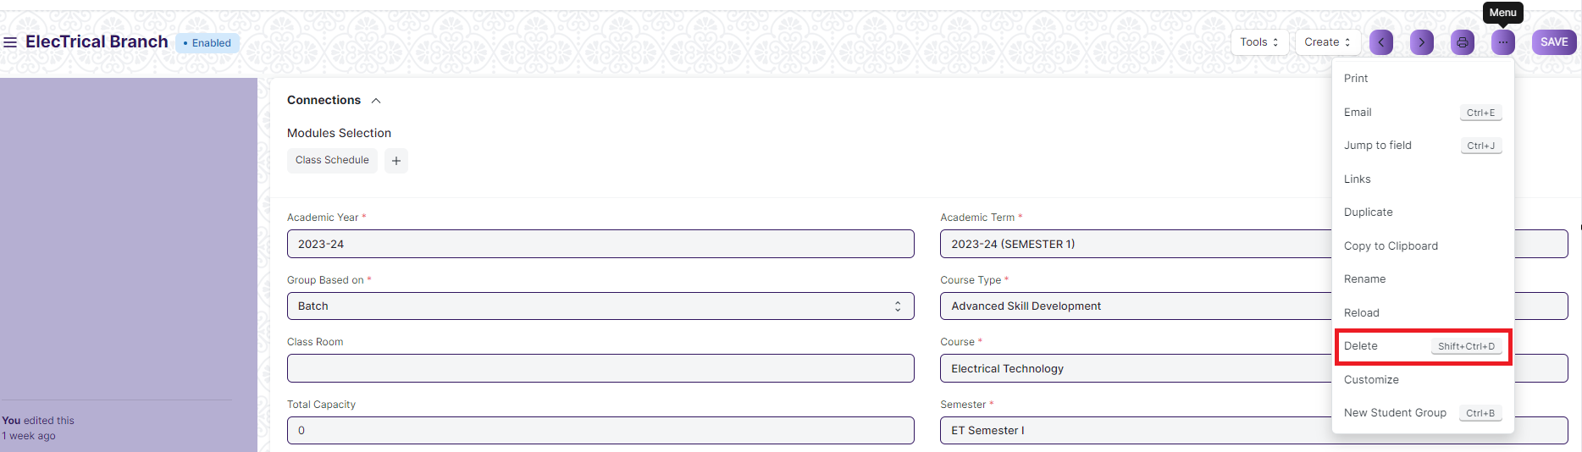

(Example : Deletion of “ElecTrical Branch” document of Student Group)

1. Click yes if you want to delete the selected document.

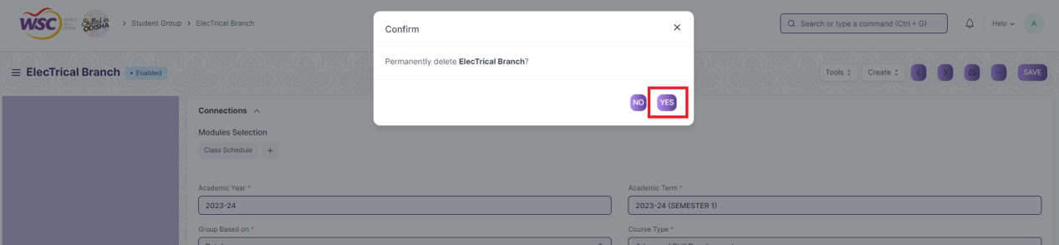

(Example : Clicking Yes to Delete permanently the document)

**Note :** The process of deletion can only be carried out by user who have necessary permission. Kindly refer to the Screen wise permission section in the document.

**Rename a Saved Document**

1. Login to the screen.
2. Go to the required workspace
3. Go to the required screen.
4. Click on the required document from the list view of the screen.
5. Click on the 3 dots in the right corner of the screen.
6. Click on *“****RENAME”*** .

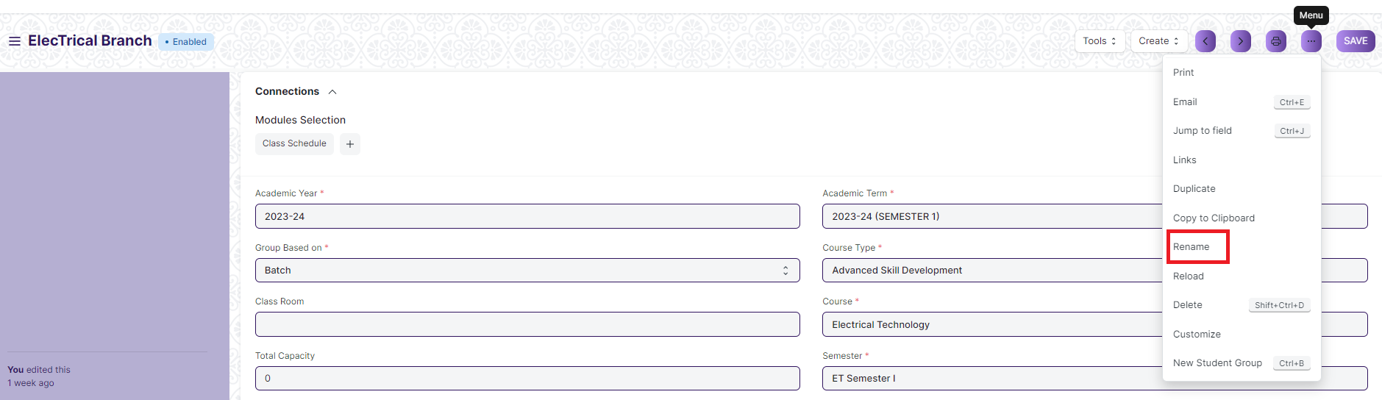

1. Click on *“****Rename”*** button to rename the document.

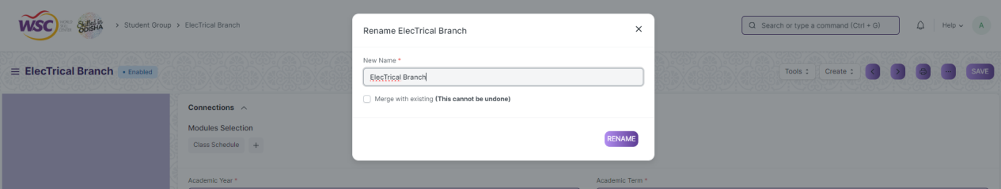

**Note :** The process of deletion can only be carried out by user who have necessary permission. Kindly refer to the Screen wise permission section in the document.

**Print a Saved Document type**

1. Login to the system
2. Go to the required workspace
3. Go to the required screen.
4. Click on a saved document in the screen.
5. Click on the print button present in the right corner of the screen.

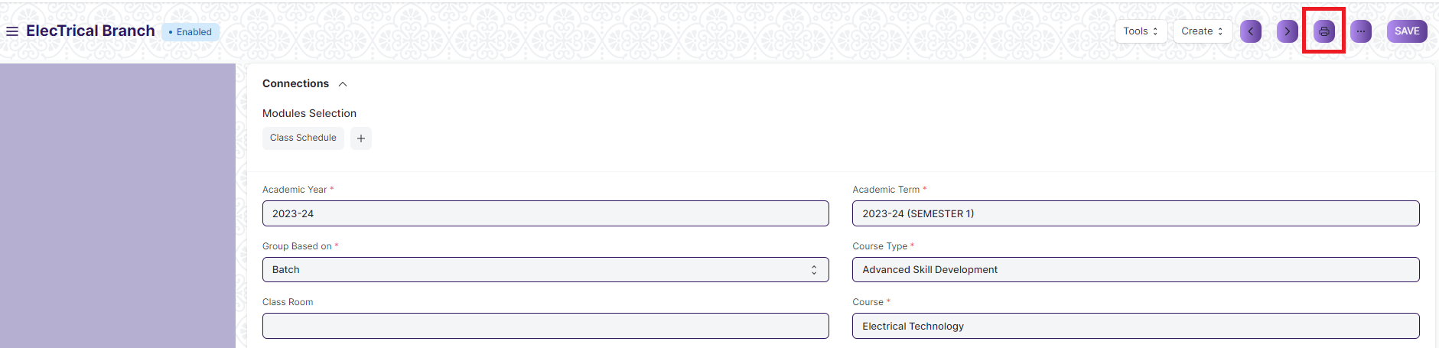

1. A new screen will open.
2. Click on the print button to Print the document.

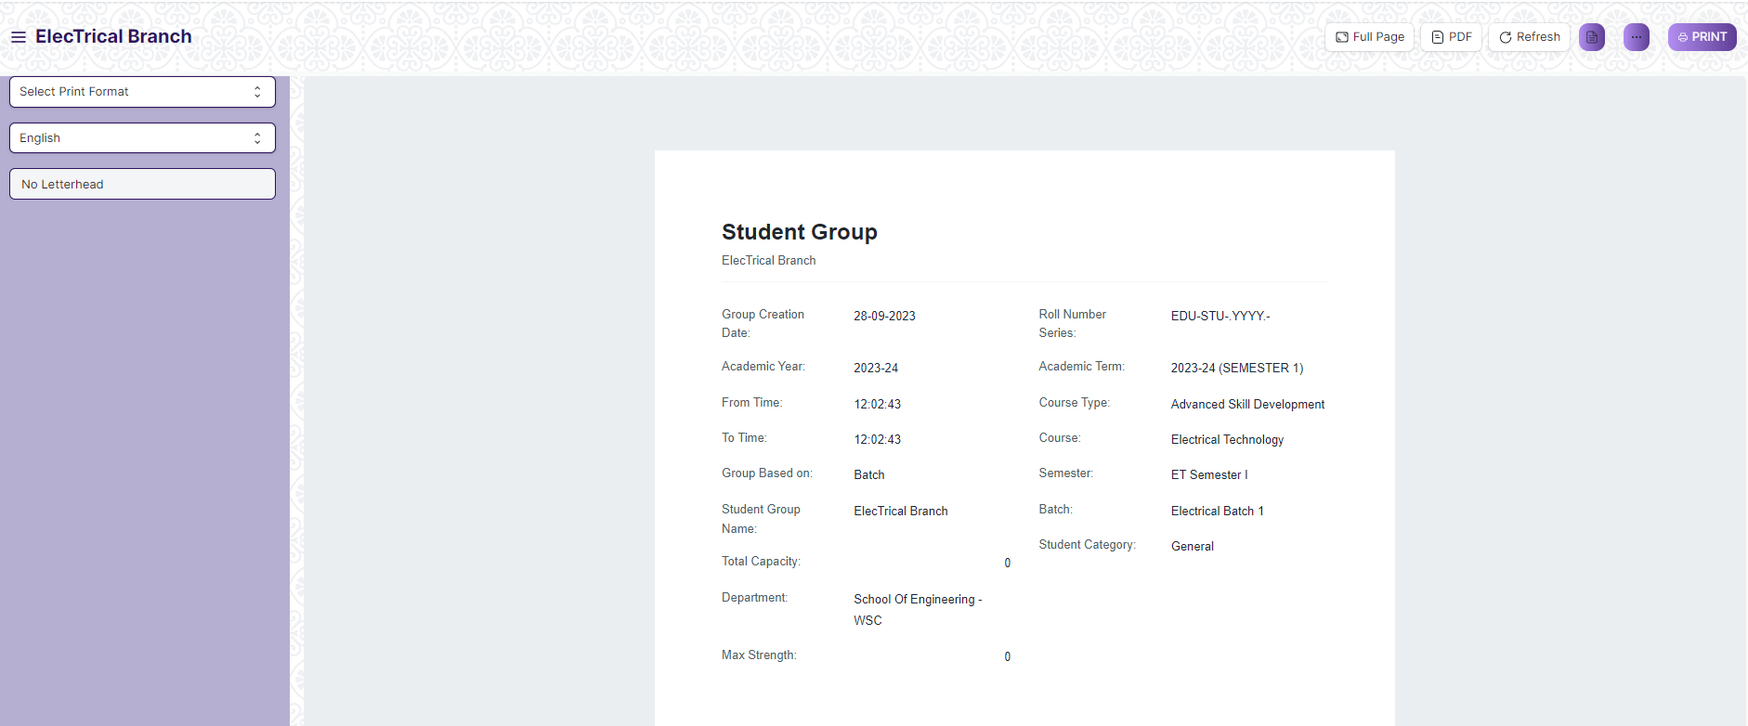

1. To download the employment type as PDF , click on the PDF button .

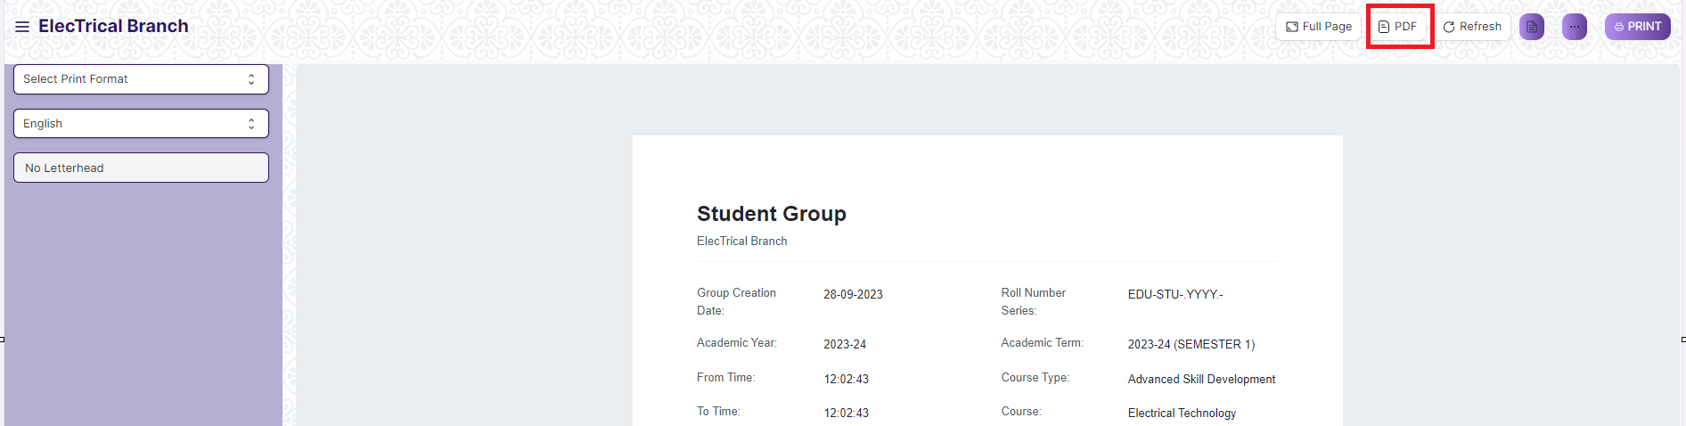

**Note :** The process of printing can only be carried out by user who have the necessary permission.

**View the saved document in different format.**

1. Login to the system
2. Go to the required workspace
3. Go to the required screen.
4. Click on the List View Button in the screen.

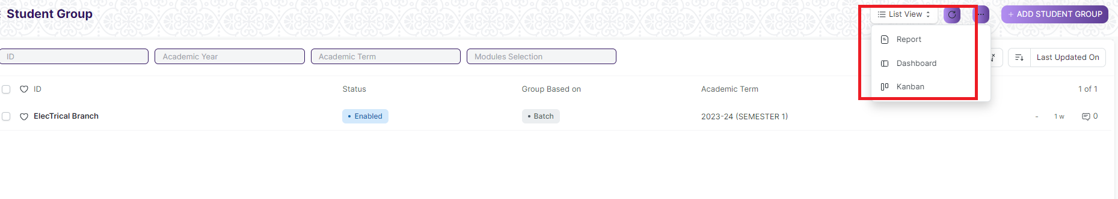

1. Select the appropriate view type that you want.

**Note :** The List view button can only be showed to the user who have necessary permission.

**View the saved documents by applying filters.**

1. Login to the screen.
2. Go to the required workspace.
3. Go to the required screen.
4. Click on the ***“Filter”***.

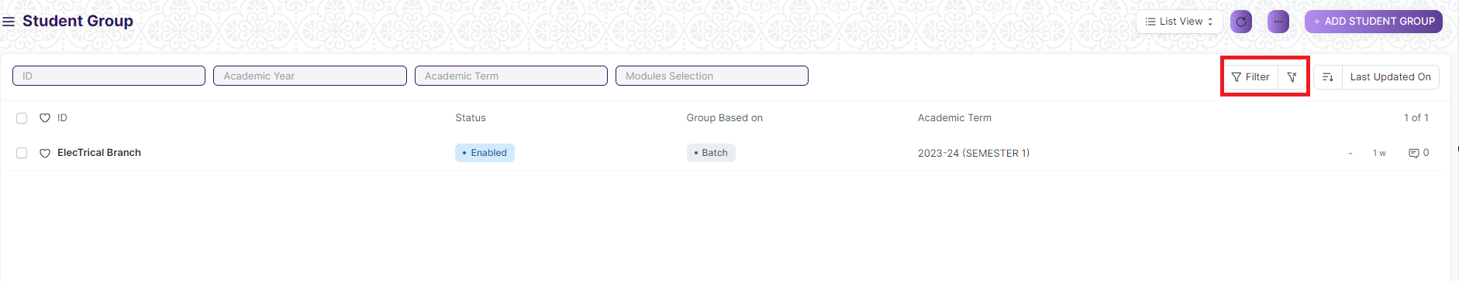

1. Select the field of the document based on which you wish to filter the records. All the fields in a form will be selectable in this list.

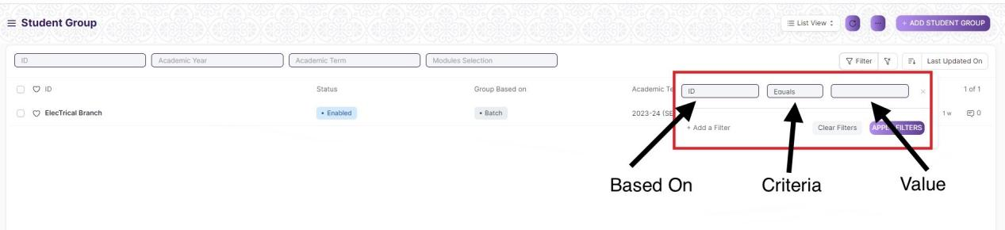

**Based On :** For the field, you will be required to put a value of the field. In the 'based on' field.

**Criteria :** You can define criteria based on which the system will search the document.The different conditions on which the filters are based are: Equals, Not Equal, Like, Not Like, In, Not In, =,>,< etc.

**Value :** Here, you will be required to enter the value for which you are running the document search.

**Some Examples of Viewing the documents in the list view after applying filters.**

Filter on Student Group screen where Group Based On to Batch. After clicking the Apply Filter button, all the filtered document will show in the screen.

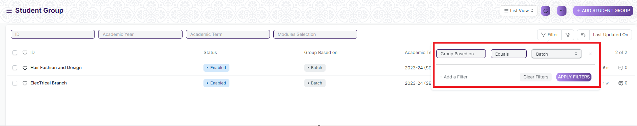

Filter on Student Group Screen where, the Academic Year is equal to 2023-24.

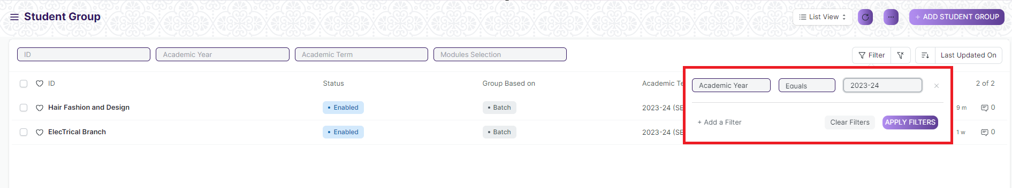

You can also apply multiple filters at a time. To remove a specific filter, just click on 'x' sign on it. To add another filter Click on the +Add a Filter button.

**Example of Multiple filter .**

Applying filter in the Student Group screen ,n where Group Based On to Batch and Academic Year is equal to 2023-24.

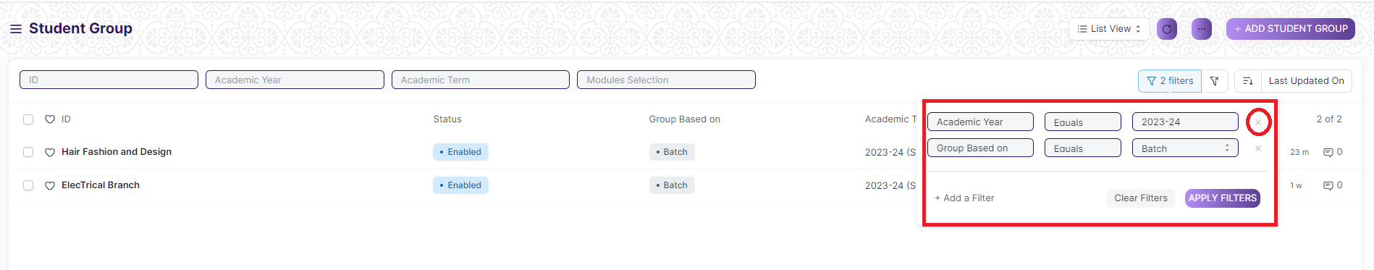

**Default Filters**

There are some filters present out of the box for the views which can be used for filtering the search results.

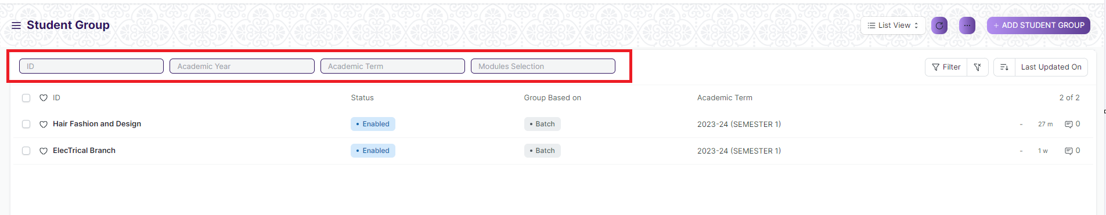

**Note :** The Filter Option can only be showed to the User who have necessary permission.

### **General Procedure for a Submittable Screen**

**Create of New document**

1. Login in to the system
2. Go the required workspace
3. Go to the required screen.
4. Click on the ***“+Add Screen Name”*** button in the right corner of the screen.

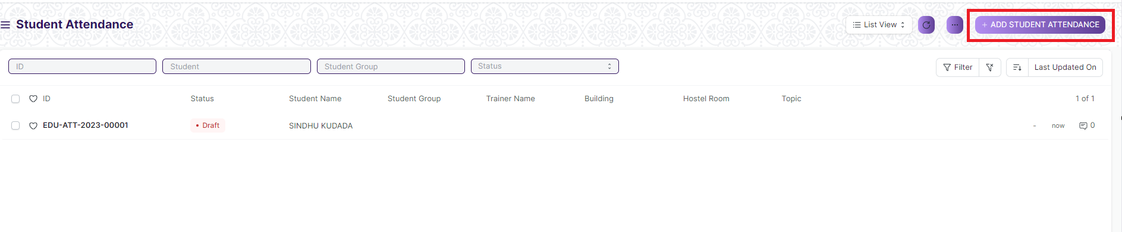

(Example : For addition in the new Student Attendance Type , click +Add Student Attendance button).

1. Enter the required information in the document.
2. Once you are finished entering the information , click the ***“Save”*** button.
3. After saving it , a submit button will appear.

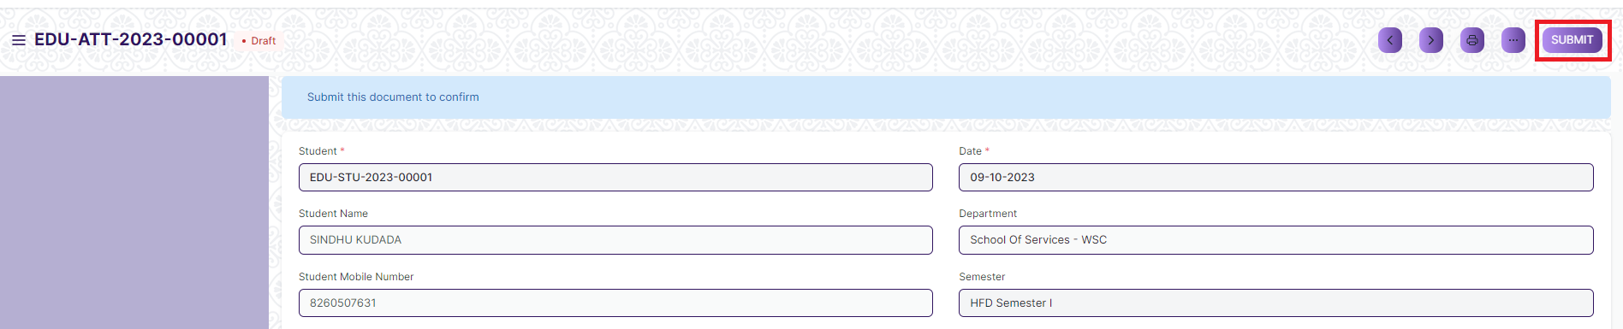

1. Click on the **“Submit”** button.
2. A confirmation dialog box will appear . Click the Yes button to submit the document.

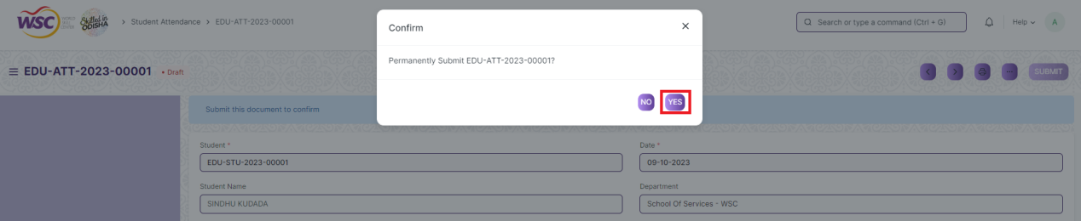

1. After submitting , the record will be visible in the List View of the screen.

**Note :** The process of creation can only be carried out by user who have necessary permission. Kindly refer to the Screen wise permission section in the document.

**Cancel a Submitted Document**

1. Log in to the system.
2. Go to the required workspace
3. Go to the required screen.
4. Click on the required document from the list view of the screen.
5. Click the ***“Cancel”*** Button .

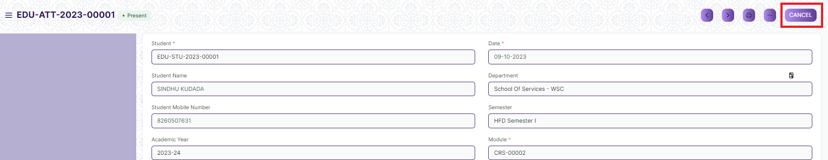

1. A confirmation dialog box will appear . Click the Yes button to cancel the document.

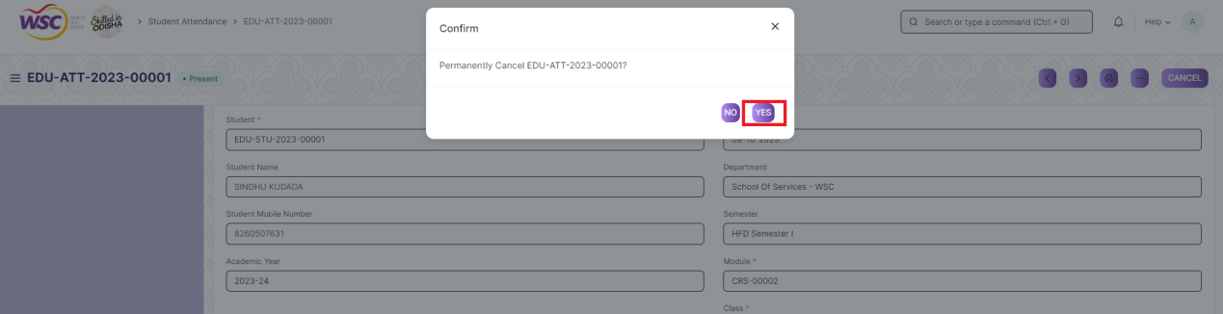

**Note :** The process of cancellation can only be carried out by user who have necessary permission. Kindly refer to the Screen wise permission section in the document.

**Amend a Submittable Document**

1. Log in to the system.
2. Go to the required workspace
3. Go to the required screen.
4. Click on the required document from the list view of the screen.
5. After cancellation of the document , an Amend button will appear on the screen.

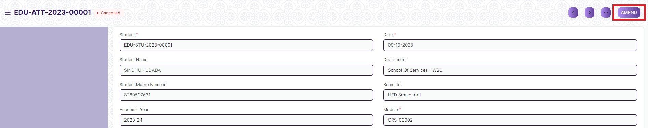

1. Click the “***Amend”*** button.
2. A new document will be created with the same information as the original document .

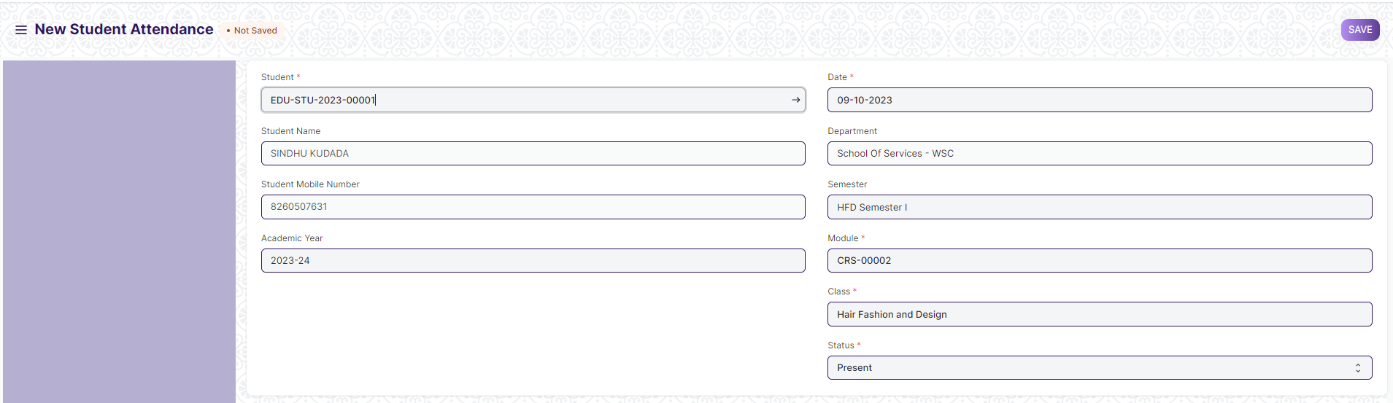

1. You can now make changes to the document as needed.

**Note :** The process of Amend can only be carried out by user who have necessary permission.Kindly refer to the Screen wise permission section in the document.

**Action Menu on a document.**

The three dots menu, located in the right corner of a document in a Screen , offers a range of actions and options to manage and interact with the document.

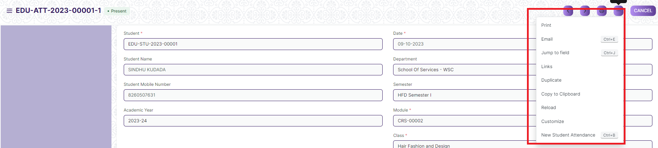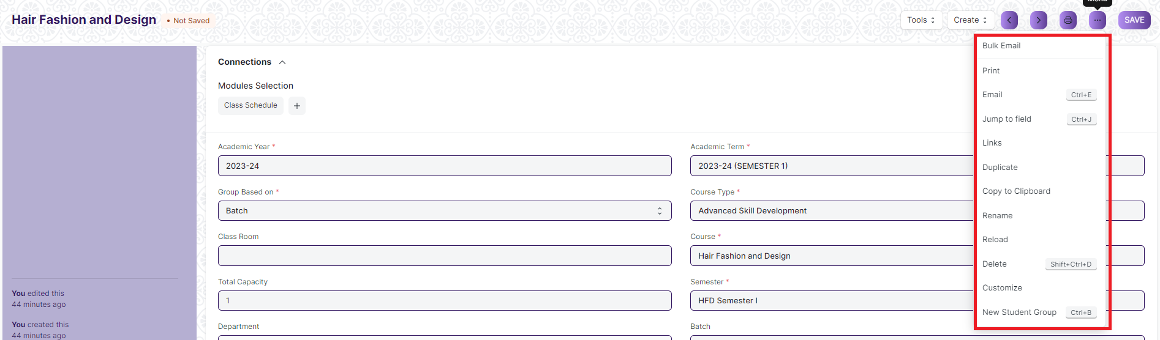

The functionalities available in the three dots menu are given below .

**Print :** Print Enables you to generate a printable version of the document ., which you can save as a PDF or send to a printer.

**Email/Bulk Email :** Click on Email allows you to send the document as an attachment via email to specified recipients.

**Duplicate :** Create a new document with the same information as the current one.

**Delete :** Permanently remove the document.

**Cancel :** Cancel the submitted document.

**Submit :** Submit the document . If the document is submittable.

**Links :** This Option displays a list of document that are linked to the current document. You can navigate these linked documents from here.

**Jump to field :** You can directly go the required field by clicking this option and giving appropriate field name.

**Copy to Clipboard :** By clicking this option you can copy the content of the document .

**Rename :** By clicking the Rename option you can Rename the document.

**Note :** These options will be visible to User who have necessary permission.

### Student Group

The Student Group allows you to create a group of students for different classes for the ongoing Academic Year based on different criterion like:

1. Batch
2. Exam Declaration
3. Course
4. Activity
5. Combined Course
6. Mentor-Mentee

To access the Student Group Process, go to:

**Home > Academics > Group & Schedules > Student Group**

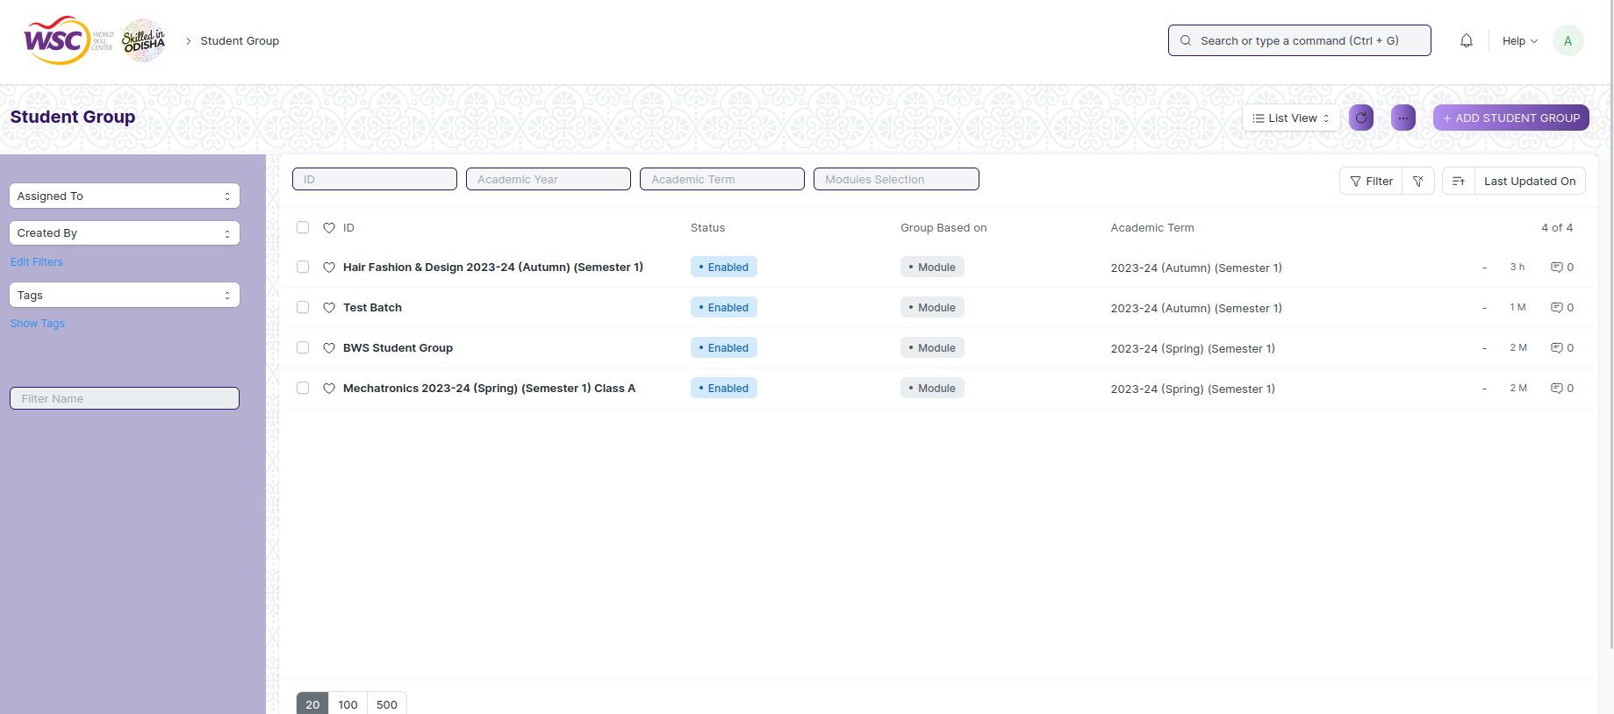

### Prerequisites

Before creating a Student Group, it is advisable that you create the following first:

1. Student
2. Class Enrollment
3. Student Batch Name
4. Student Category
5. Instructor

### How to create a Student Group

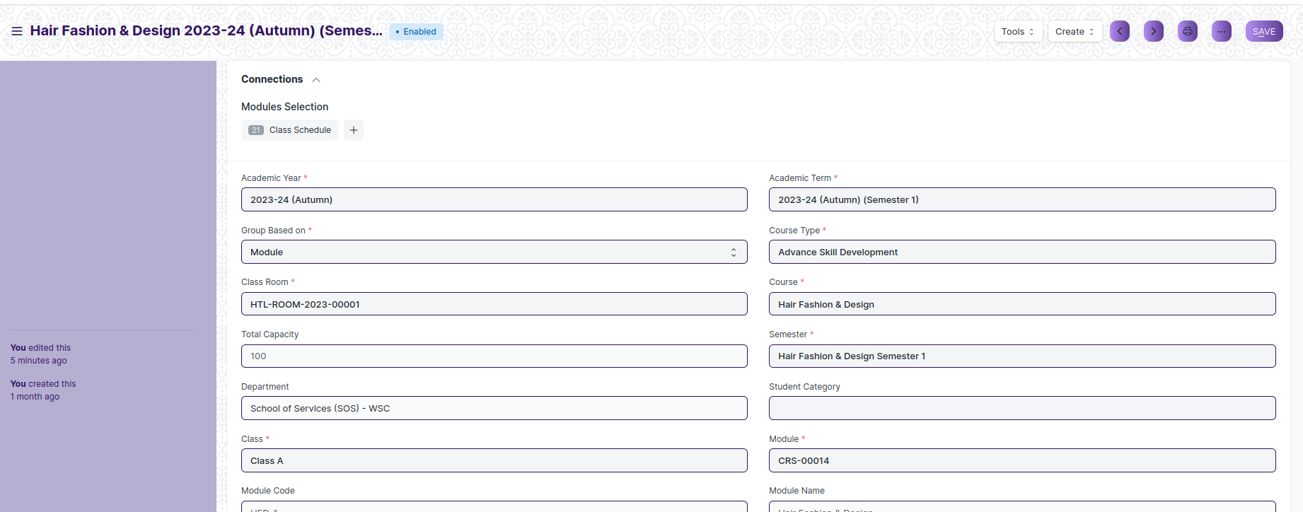

1. Go to the Student Group list and click on ‘Add Student Group’
2. Select and enter the Academic Year
3. Select and choose from the drop-down list for ‘Group Based on’.
4. Batch- Select and enter Class, Section and Batch (from the drop-down).
5. Course- Select and enter Class, Section and Course (from the drop-down).
6. Section- Select and enter Class and Section.
7. Activity- Select and enter Class and Section.
8. Exam Declaration- Select and enter Class, Course and Exam Declaration.
9. Enter the name for the Student Group
10. Select and Enter the classroom from the drop-down list.
11. Select and Enter the maximum strength.
12. Select and Enter the Student Category(ST/General) from the drop-down list.
13. In the ‘Instructor’ table, enter the details like Course and associated Instructors for the particular Class or Section.
14. Click on Save.

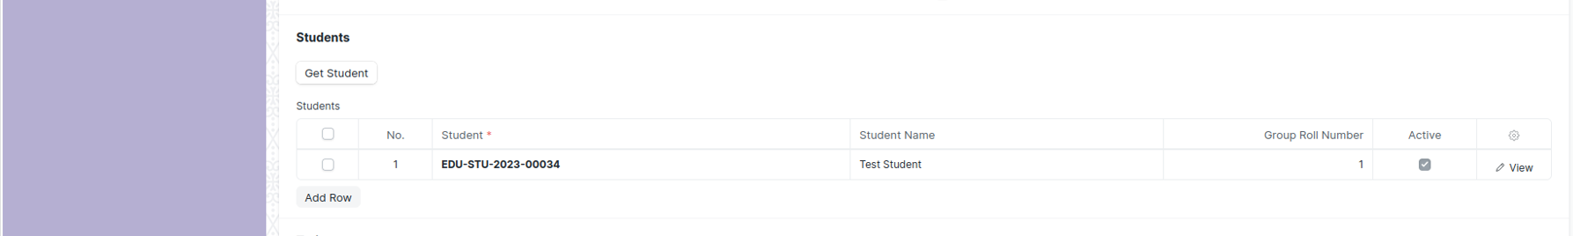

1. After save Click on the ‘Get Student’ button, all the students present will automatically be fetched on the basis of ‘Group Based On’.

### Class Schedule

The Class Schedule can be used for scheduling a particular Class by an Trainer.

To access the Class Schedule, go to:

**Home > Academics > Group & Schedules > Class Schedule**

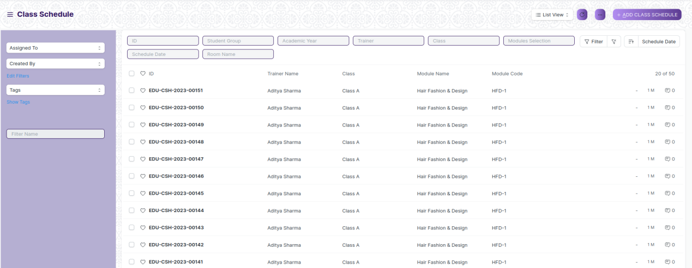

### Prerequisites

Before creating a Class Schedule, it is advisable that you create the following first:

1. Student Group
2. Trainer
3. Module
4. Class
5. Room

### How to create a Class Schedule

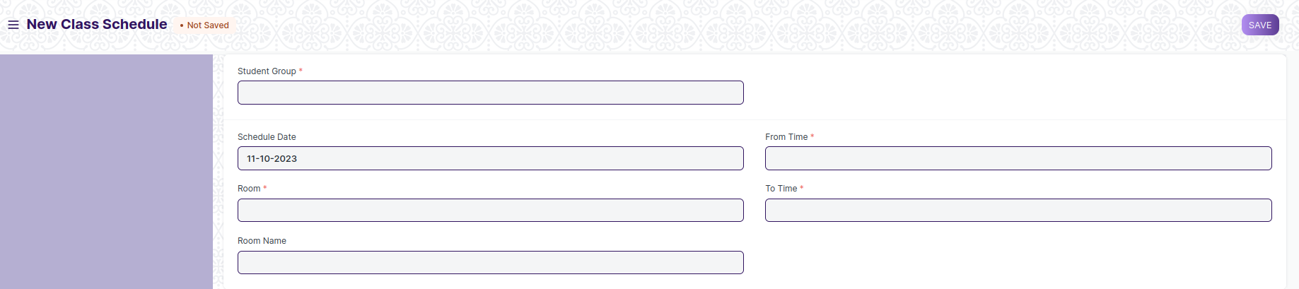

1. Go to the Class Schedule list and click on ‘Add Class Schedule’.
2. Select and enter the Student Group.
3. Select and enter the Trainer who will be tutoring the students for the module.
4. Select and enter the Module from the drop down menu for which the schedule is being prepared.
5. Select and Enter the ‘From Time’ and ‘To Time’ for the class schedule.
6. Select and Enter the Room where in the class could be conducted.
7. Click on Save.

**Note**: Class Scheduling Tool can be used for bulk scheduling of a course.

### Student Attendance

The Student Attendance allows you to keep track and mark the attendance of a student for a day. Attendance records can be created against Students on a daily basis.

To access the Student Attendance process, go to:

**Home > Academics > Attendance & Leave Application > Student Attendance**

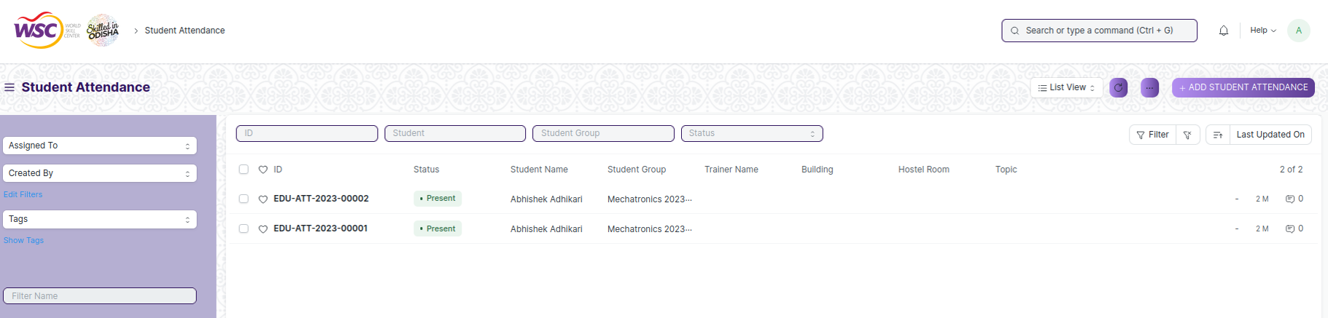

### Prerequisites

Before creating a Class Schedule, it is advisable that you create the following first:

1. Student
2. Class Schedule
3. Student Group

### How to create a Student Attendance

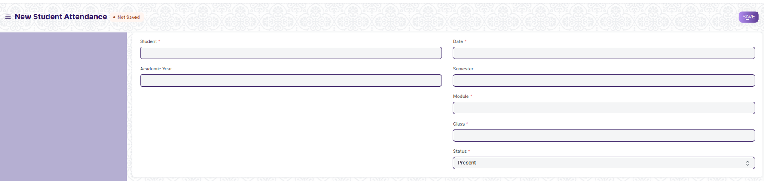

1. Go to the Student Attendance list and click on ‘Add Student Attendance’.
2. Select and enter the Student.
3. Select and enter date and module.
4. Select and enter the Student Group and Class Schedule.
5. Set the Status to Present/Absent/On Leave.
6. Click on Save and Submit.

**Note**: The Attendance can be marked for the Exams and also the Student Attendance Tool can be used for bulk updation of the attendance.

### Student Attendance Tool

The Student Attendance Tool allows you to bulk update the Attendance for Students based on Student Group and Class Schedule.

To access the Student Attendance Tool process, go to

**Home > Academics > Attendance & Leave Application > Student Attendance Tool**

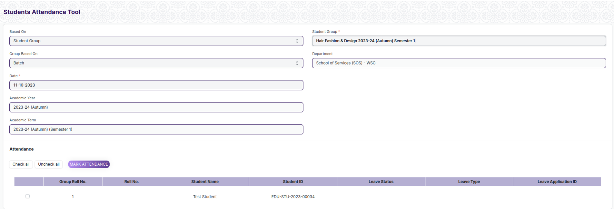

### Prerequisites

Before creating a Class Schedule, it is advisable that you create the following first:

1. Student
2. Class Schedule
3. Student Group

### How to create a Student Attendance Tool

1. Go to the Student Attendance Tool.
2. Select and Enter the ‘Based On’ from the drop-down menu
3. Student Group: Select and Enter ‘Group Based On, Student Group, Academic Year and Date.
4. Class Schedule: Select and Enter Academic Year and Class Schedule.
5. Students will be automatically fetched.

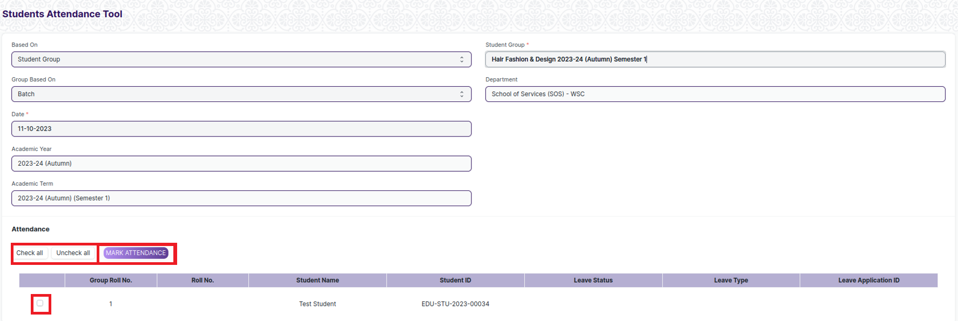

1. Mark the Attendance.

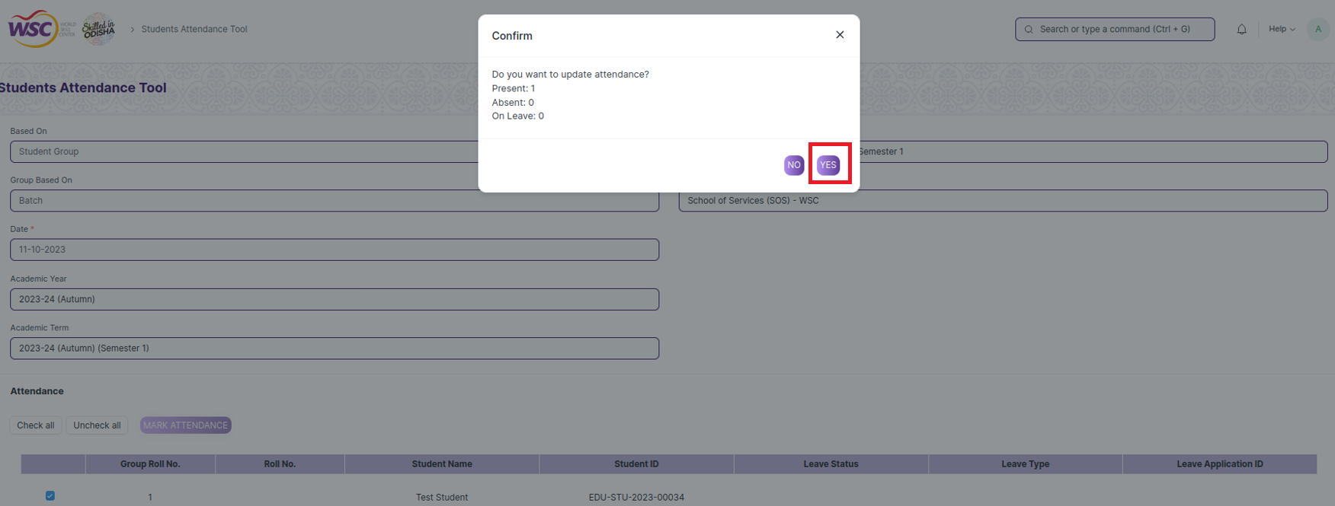

1. Click on Yes

**Note**: The entries for all the Students Attendance Tool is created in the Student Attendance Document.

### Reason for Leave

Reason for Leave is a Master Data and this data is used for Leave application for student.

To access the Reason For Leave process, go to

**Home > Academics > Attendance & Leave Application > Reason For Leave**

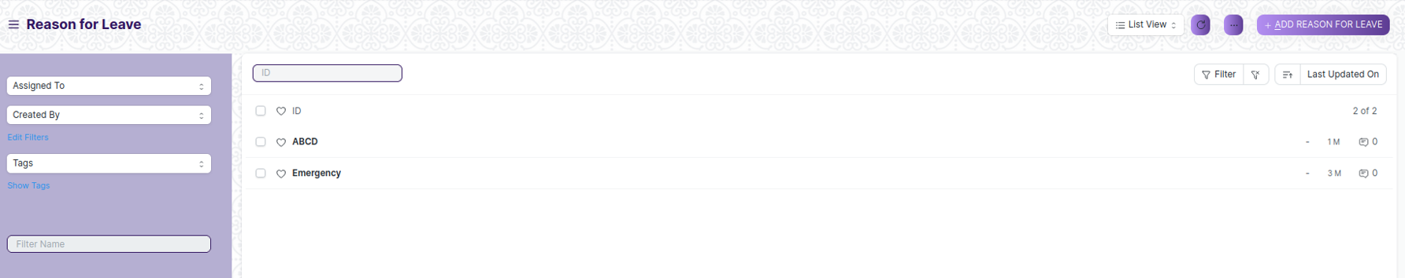

### How to create a Reason for Leave

1. Go to the Reason for Leave and Click on ‘Add Reason for Leave’.



1. Enter Reason
2. Click on Save

### Class Advisor and Manager Assignment

The Class Advisor and Manager Assignment form assisgns eligible advisor, manager and deputy director to receive notifications for the leave application process and take necessary actions for specified students.

To access the Student Leave Application process, go to:

**Home > Academics > Attendance and Leave Application > Class Advisor and Manager Assignment**

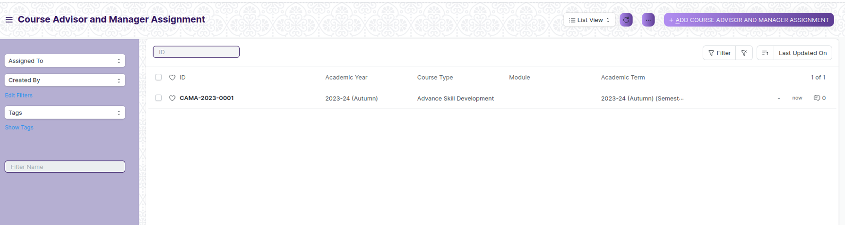

### Prerequisites

Before creating a Class Advisor and Manager Assignment, it is advisable that you create the following first:

1. Academic Year
2. Academic Term
3. Course Type
4. Class
5. Course
6. Semester
7. Student
8. Trainer

### How to create a Class Advisor and Manager Assignment

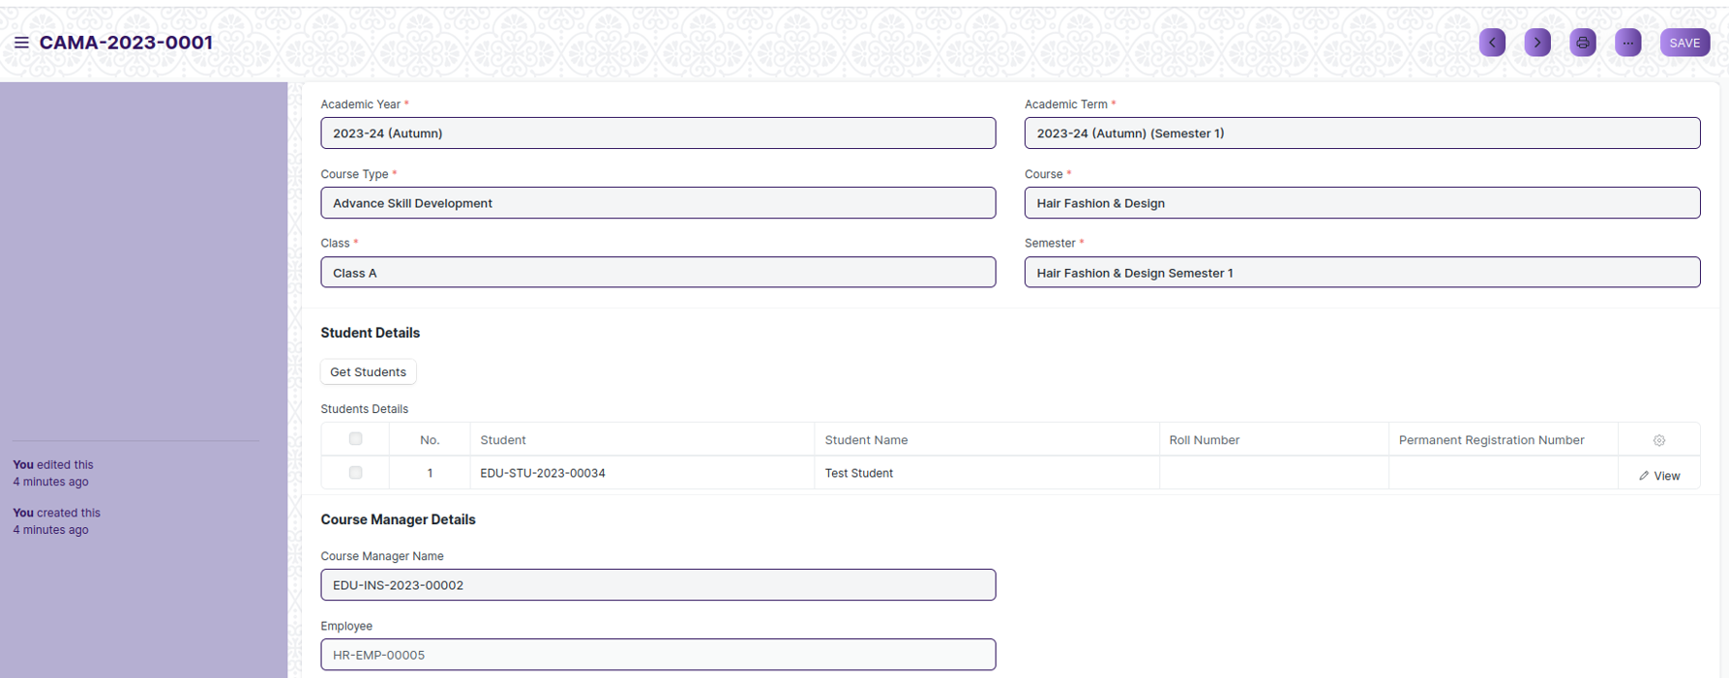

1. Go to the Class Advisor and Manager Assignment list and click on ‘Add Class Advisor and Manager Assignment’.
2. Select Academic Year, Academic Term, Course Type, Course, Class and Semester.

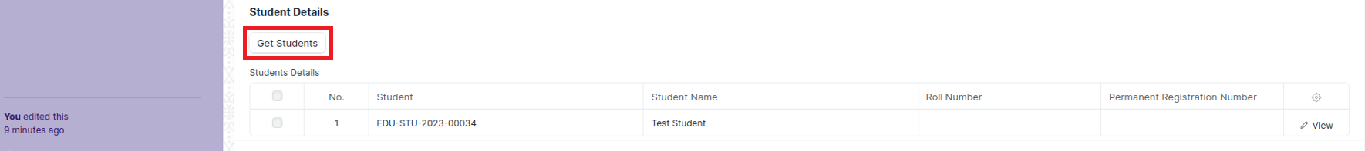

1. Click on Get Student Button and then student will fetch on table..
2. Select Course Manager Name, Course Advisor Name and Employee then according to selected field all data will fetch.
3. Click on save

### Student Leave Application

The Student Leave Application allows you to keep a track of leaves for a Student.

To access the Student Leave Application process, go to:

**Home > Academics > Attendance and Leave Application > Student Attendance**

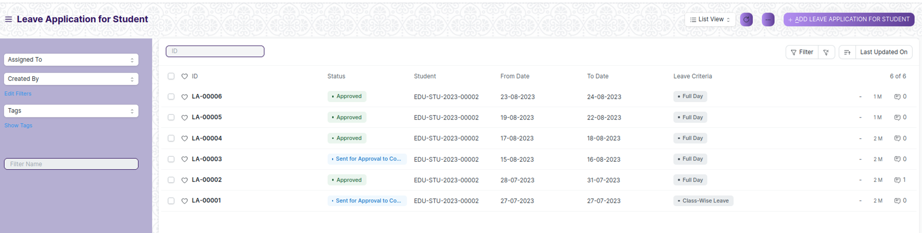

### Prerequisites

Before creating a Student Leave Application, it is advisable that you create the following first:

1. Student
2. Leave Type (Reason for Leave)

### How to create a Student Leave Application

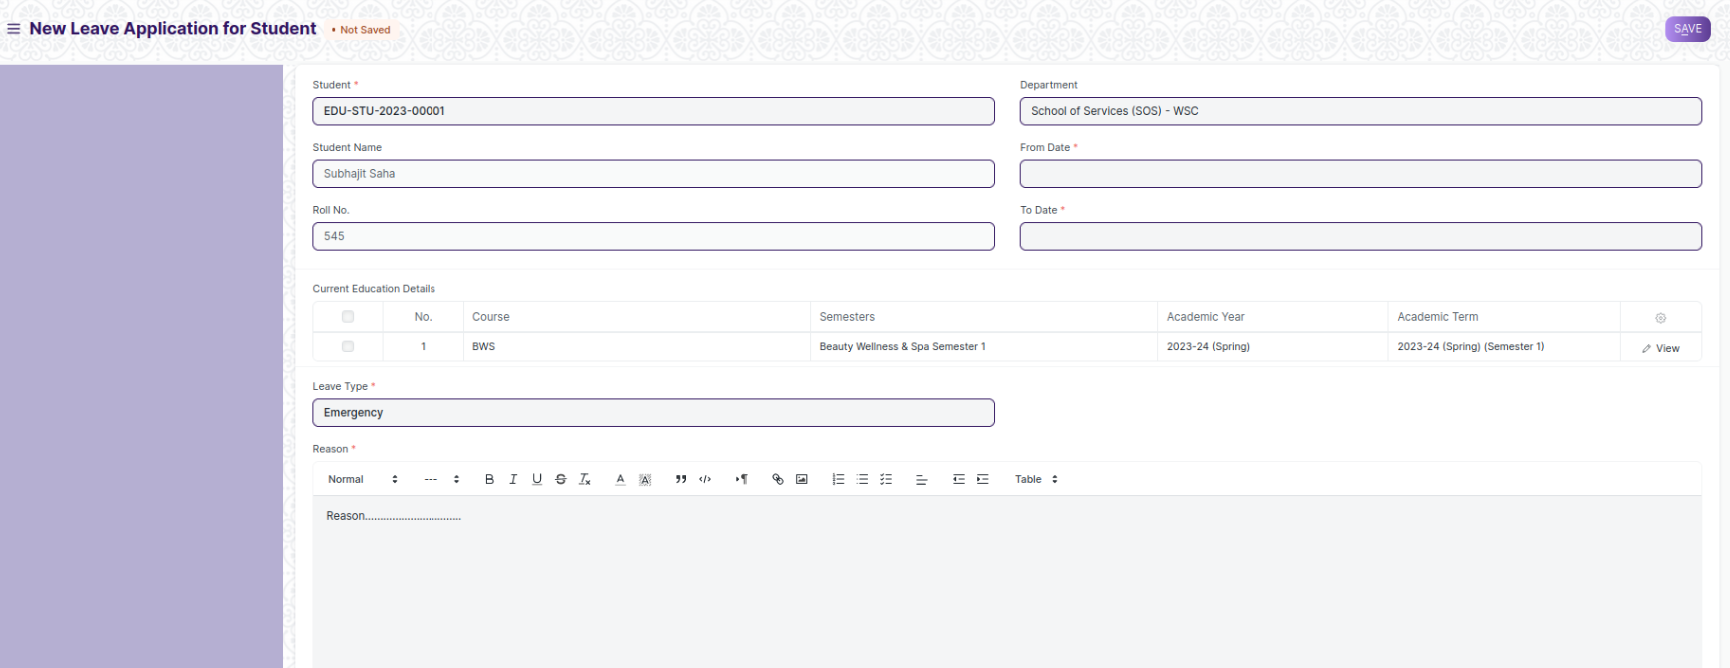

1. Go to the Student Leave Application list and click on ‘Add Student Leave Application’.
2. Enter Student details and all student data will auto-fetched.
3. Select and enter “From Date” and “To Date”.
4. Select Leave Type and enter Reason.
5. Click on Save.

### Mentor Allocation

Mentor Allocation is a process in which Mentors (Trainer) are allocated to different student groups or students on various basis

To access Mentor Allocation, go to:

**Home > Academics > Mentor-Mentee > Mentor Allocation**

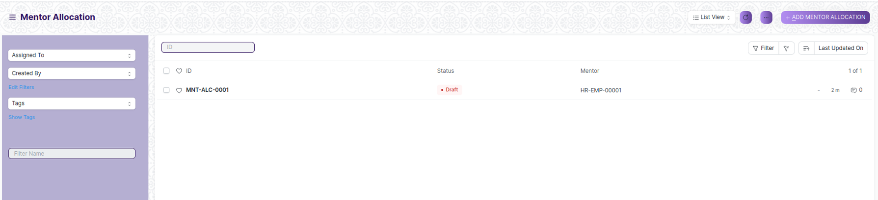

### Prerequisites

Before creating a Mentor Allocation, it is advisable that you create the following first:

1. Student
2. Trainer
3. Academic Year
4. Course

### How to create a Mentor Allocation

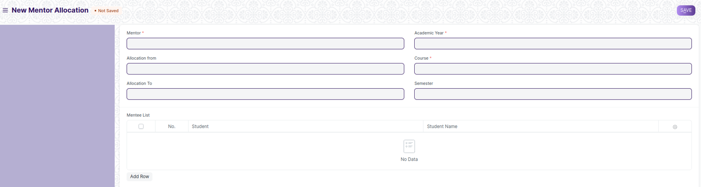

1. Go to the Mentor Allocation list and Click on add Mentor Allocation.
2. Select and add Mentor from the dropdown list.
3. Select and enter Academic Year.
4. Select and enter Course and Semester.
5. Select and enter the period in “Allocation from” and “Allocation to”.
6. Select and enter the student in Mentee List.
7. Click on Save and submit.

### Communication

As in any relationship where information is being shared on an on-going basis, you and your mentee need to interact and communicate effectively. Communicating accomplishes three basic things - It is used to get things done, to indicate feelings and thoughts, and to develop the relationship. In impersonal interactions, a minimum of these three things are accomplished. But in a mentoring relationship, the communication process should accomplish all three tasks.

To access Communication, go to:

**Home > Academics > Mentor-Mentee > Communication**

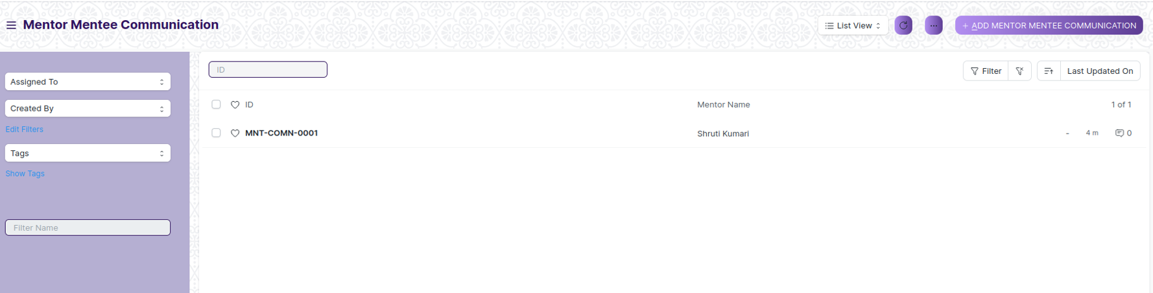

### Prerequisites

Before creating a Mentor Allocation, it is advisable that you create the following first:

1. Student
2. Mentor Allocation

### How to create a Mentor Allocation

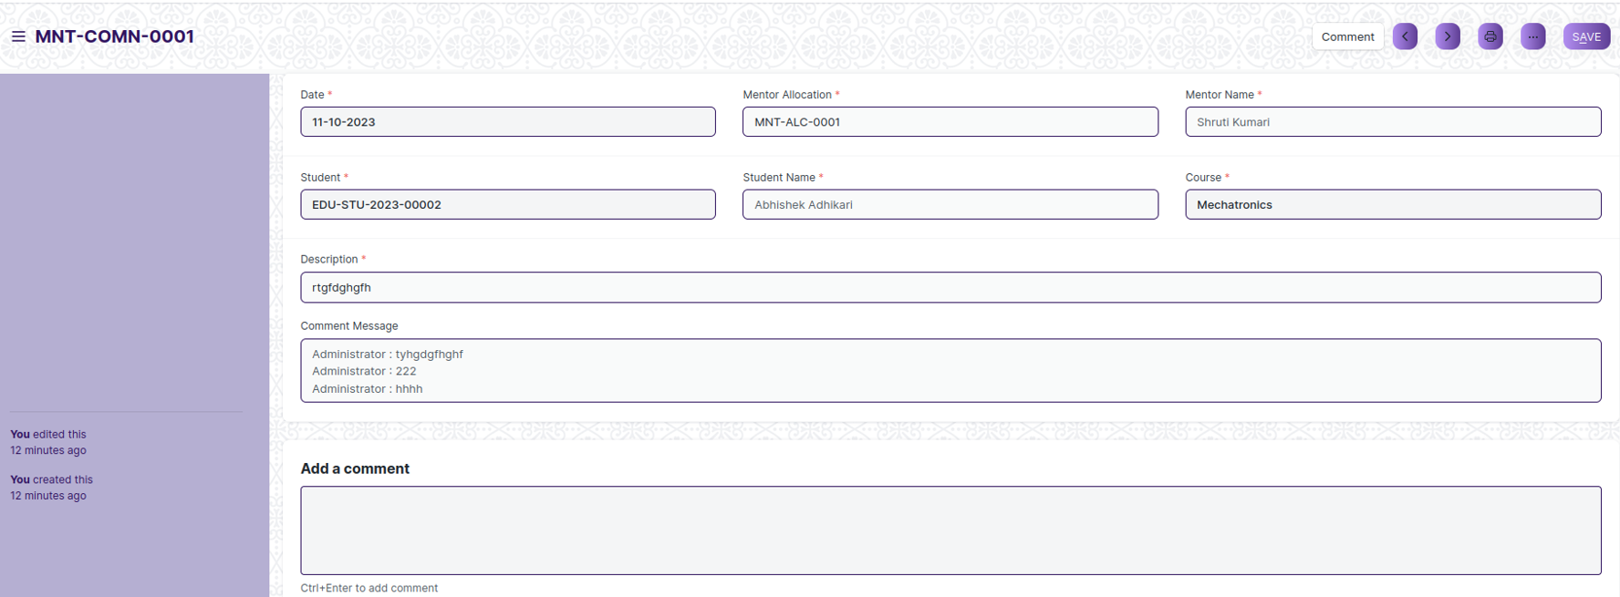

1. Go to Communication, click on add Mentor Mentee Communication.
2. Select and enter the Student for whom communication is implemented.
3. The details regarding the student and Mentor Allocation is auto-fetched.
4. Enter the details of the Communication in the Description Box.
5. Click on Save and submit.

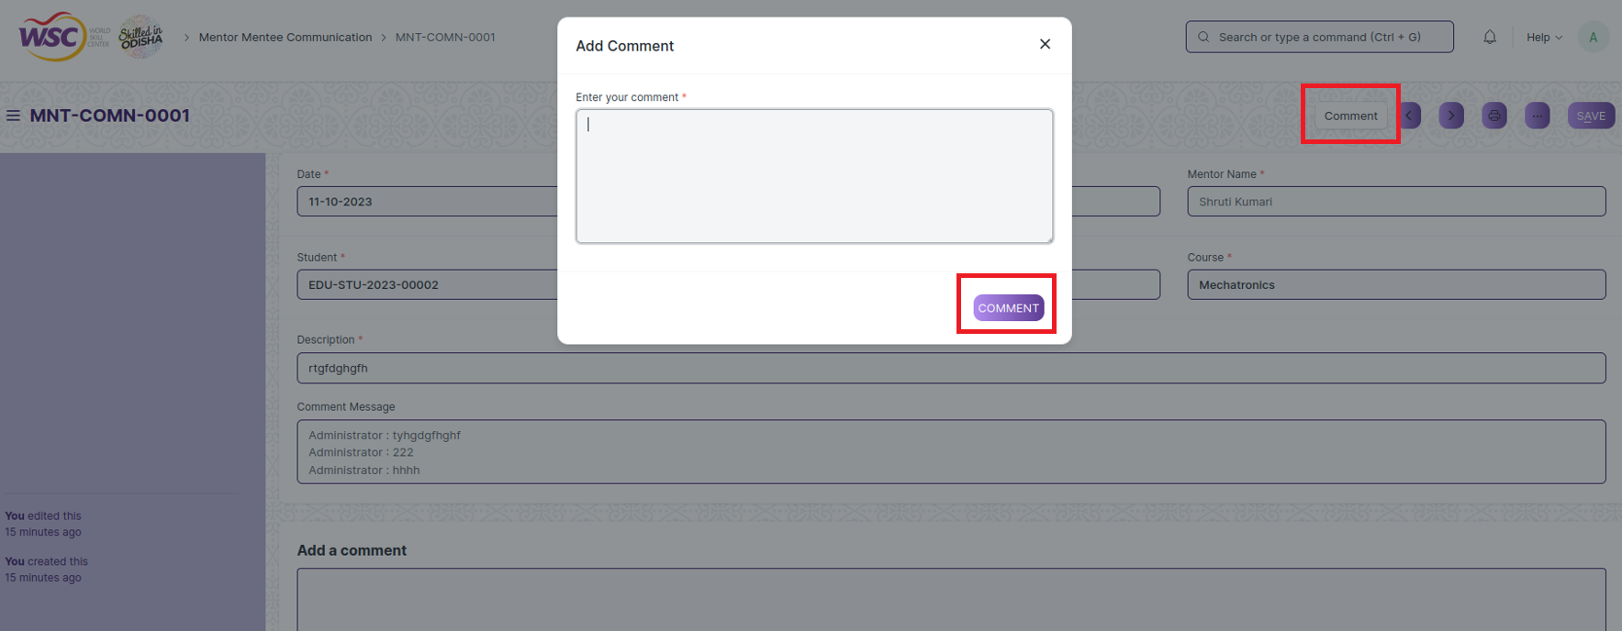

1. After that Mentor and student can give comment through comment box.

### Class Scheduling Tool

The Class Scheduling Tool allows you to create Class Schedules in bulk for the particular Module.

To access the Class Scheduling Tool, go to:

**Home > Academics > Tools> Class Scheduling Tool**

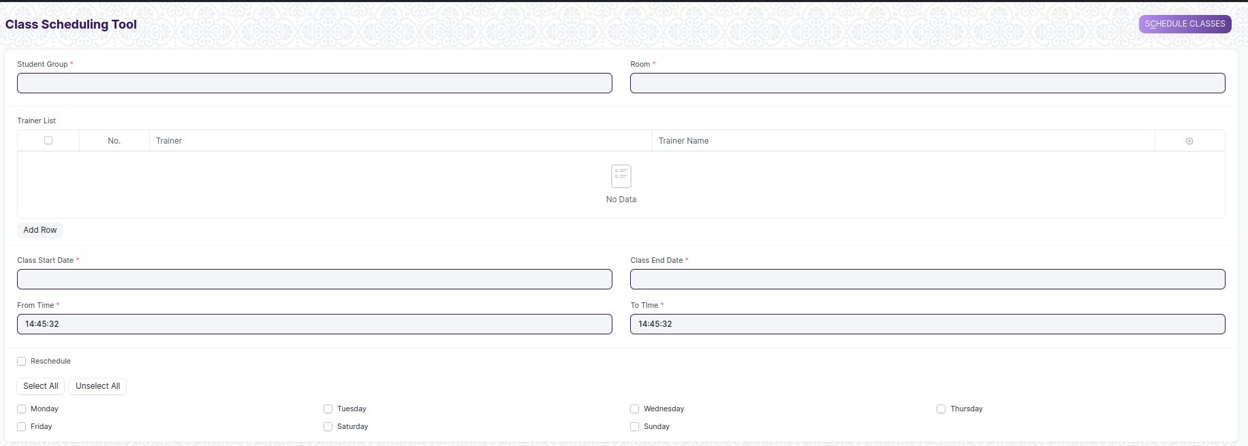

### Prerequisites

Before creating a Class Scheduling tool, it is advisable that you create the following first:

1. Student Group
2. Trainer
3. Module
4. Class
5. Room

### How to create a Class Scheduling Tool

1. Go to the Class Scheduling Tool.
2. Select and enter the Student Group.
3. Select and enter the Trainer who will be tutoring the students for the module.
4. Select and enter the Module from the drop down menu for which the schedule is being prepared.
5. Select and Enter the ‘From Time’ and ‘To Time ‘for the class schedule.
6. Select and Enter the Start Date and End Date of the Class.
7. Select and Enter the Day.

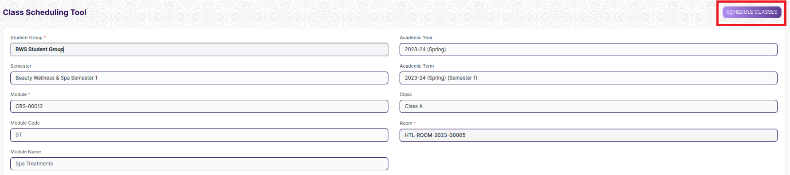

1. Click on ‘Schedule Classes’ Button.

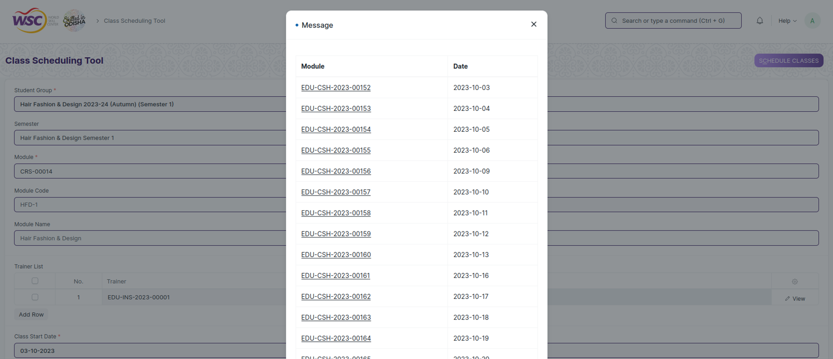

**Note**: The system will create the Class schedules if the room and Trainer are available and there is no conflict for the selected Student Group with other class schedules.

### Rescheduling:



1. You can reschedule the class schedules created.
2. Check the ‘Reschedule Checkbox and then click on ‘Schedule Classes.
3. System will delete the existing Class Schedules for the particular module within the mentioned Start Date and End Date and will create a new class Schedules.

**Note**: The entries for all the Class Scheduling Tools are created in the Class Schedule Document.

### Student Monthly Attendance

Student Monthly Attendance is a report where you can see student monthly attendance.

**Home > Academics > Reports > Student Monthly Attendance**

Here is how Student Monthly Attendance Report looks like:

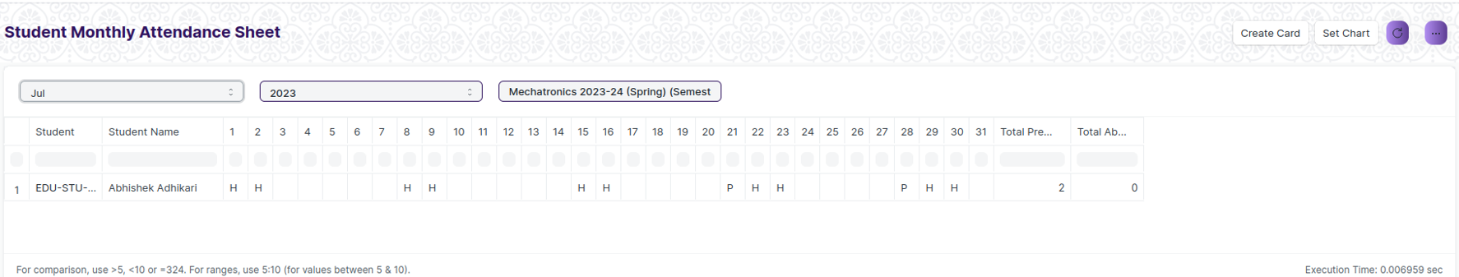

### Student Batch Wise Attendance

Student Batch Wise Attendance is a report where you can see batch-wise attendance report.

**Home > Academics > Reports > Student Batch Wise Attendance**

Here is how Student Batch Wise Attendance Report looks like:

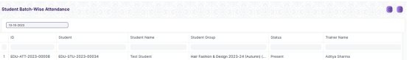

### Student Attendance Report

Student Attendance Report is detail report of attendance who are present or not and you can also view Attendance Percentage. 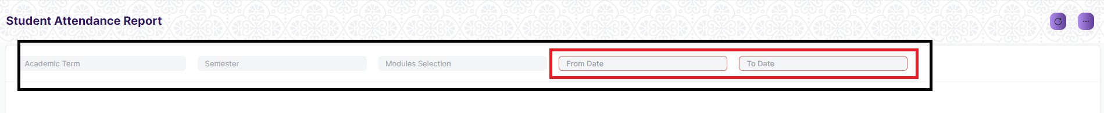

**Note**: You need to give From date and To date because without this two field report data will not fetch. You also can filter report data through Academic Term, Semester and Modules in given fields.

**Home > Academics > Reports > Student Attendance Report**

Here is how Student Attendance Report looks like:

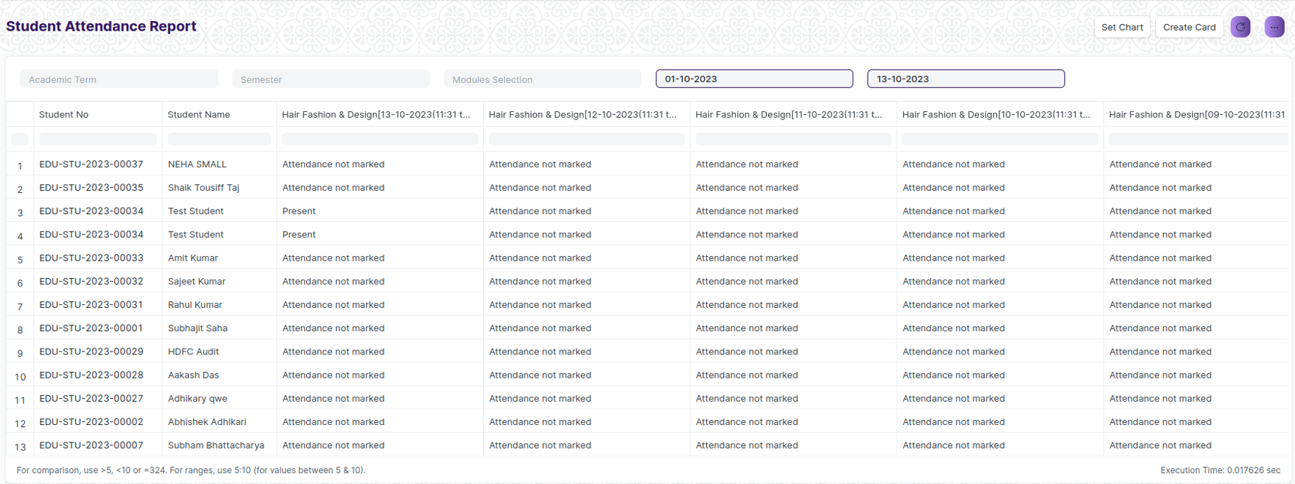

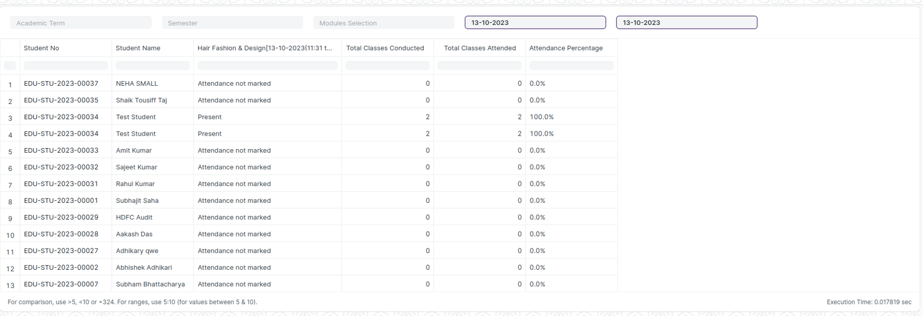

### Student Attendance Report for Billing

Student Attendance Report for Billing is detail report of student attendance that are marked or not.



**Note**: You need to give From date and To date because without this two field report data will not fetch. You also can filter report data through Academic Term and Semester in given fields.

**Home > Academics > Reports > Student Attendance Report for Billing**

Here is how Student Attendance Report for Billing looks like:

